1. Please check if your environments were ready.

node-v18.16.0-x64, python-3.11.3-amd64, yarn-1.22.4

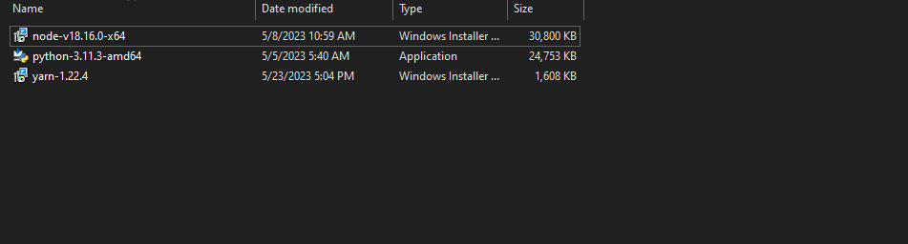

1. Please install all platforms.
2. After that, please check your source code. plantIQ-django-main, platIQ-vuejs-main

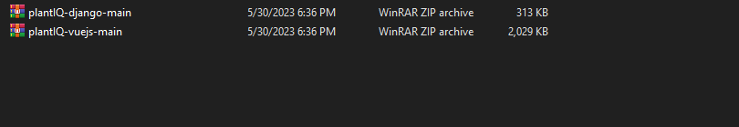

1. Extract all archived file like this.

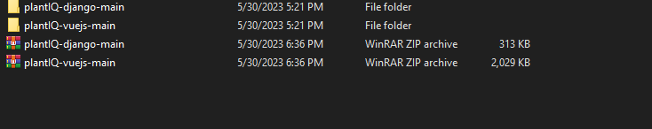

1. First, install the YARN packages for frontend(plantIQ-vuejs-main), Python packages for backend(plantIQ-django-main).

-Open your plantIQ-vuejs-main directory. Please check if there are project files. Next, Open the command prompt on this directory and run [yarn install]. Just a few miniutes for installing YARN packages.

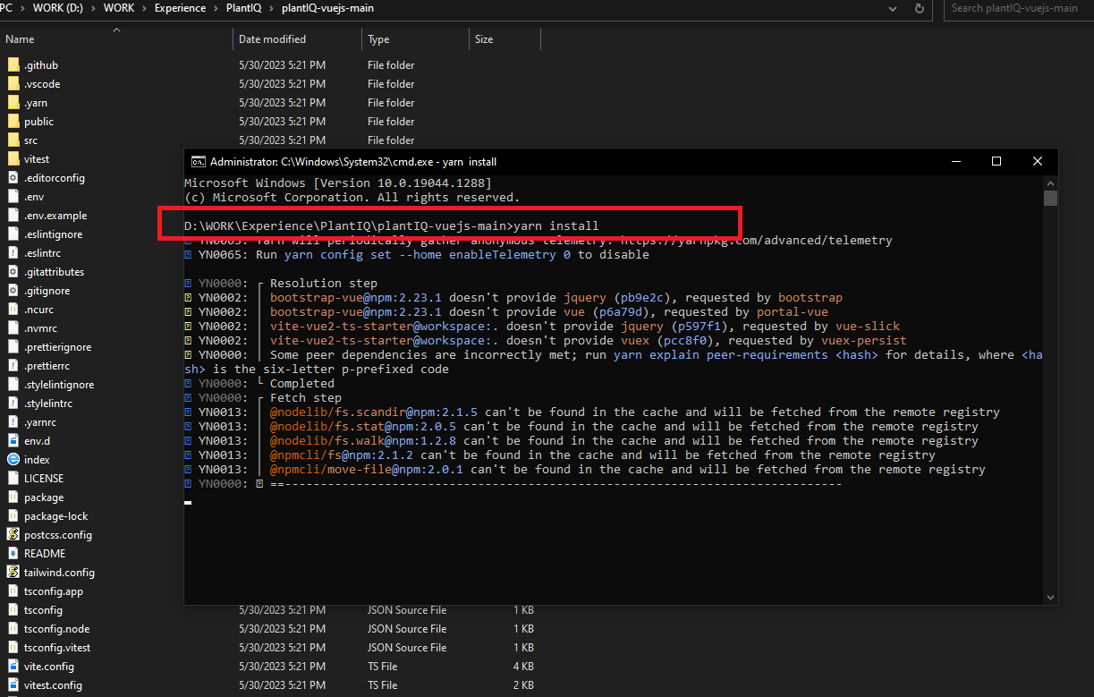

If you check SUCCESS, the installation of frontend is completed now.

-For now, It is time to install the python environment for backend(plantIQ-django-main).

Please open the [cmd, run the command “pip install -r requirement.text”], it helps to install all packages for backend.

1. For running your backend, frontend. You can run with start.bat in both of directory.

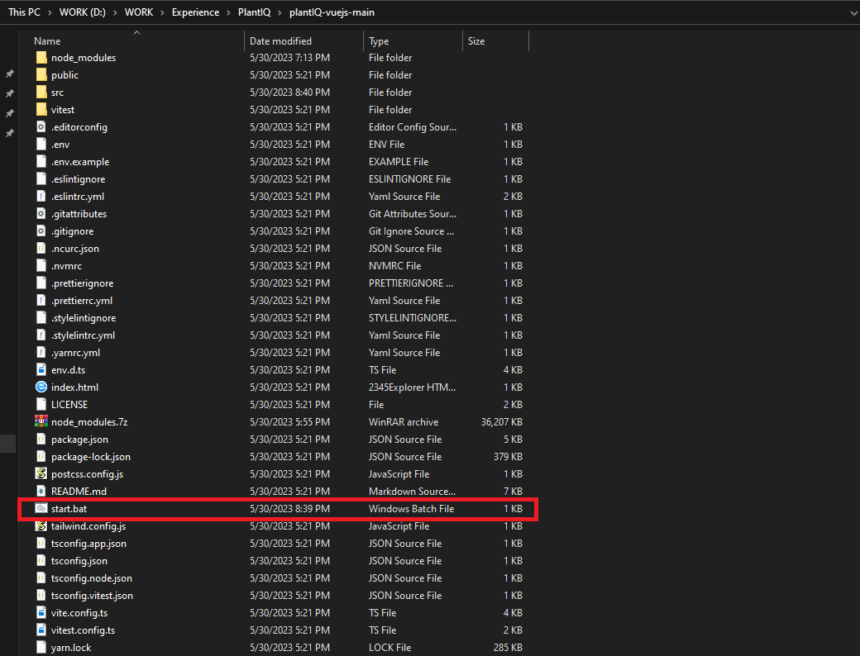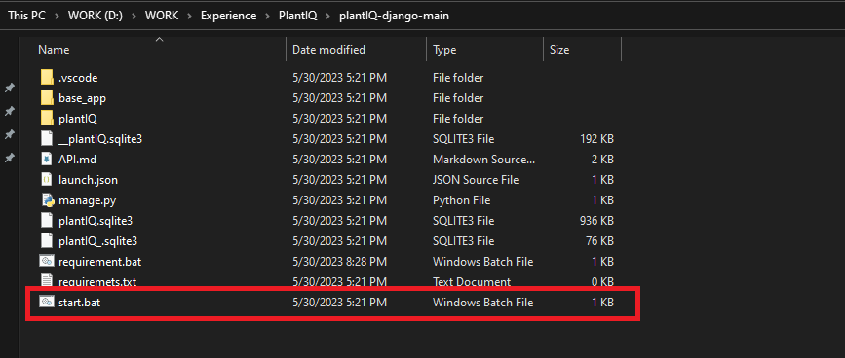

After that, you can use your application using browser like this.

